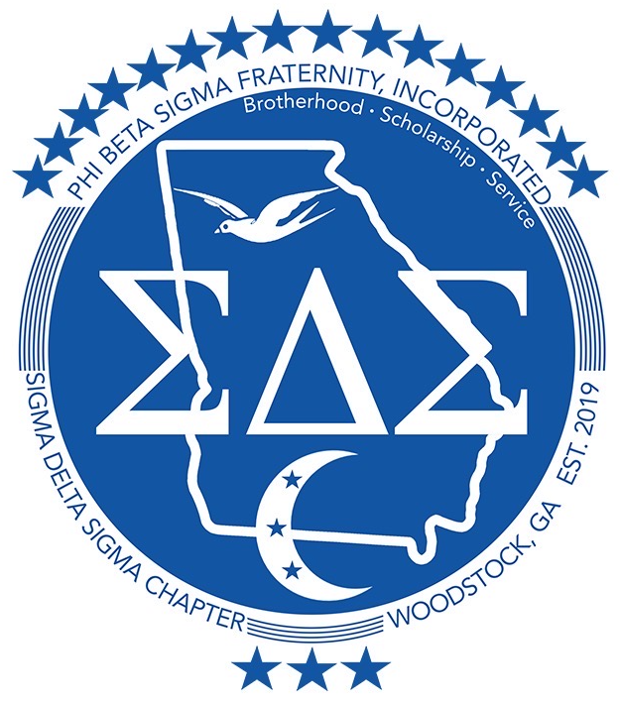
Woodstock, GA—Cherokee County

“Passing the Torch from Generation to Generation”

2025 Anna James Academic Achievement Scholarship Application

Dear Scholarship Applicant:

Thank you for your interest in becoming a part of a new tradition with the Sigma Delta Sigma Education Committee. We are currently seeking a student that exemplifies the qualities of scholarship that will be awarded by Sigma Delta Sigma Education committee.
“Passing the Torch from Generation to Generation”.

We are now accepting applications for the 2025 Anna James Academic Achievement High School Scholarship. In order to apply for this application, you must meet the following criteria:
- Must be a student presently enrolled as a high school senior at a high school located in the state of Georgia.
- Must have a minimum cumulative 3.0 GPA at the time of the application deadline.
- Should be a responsible, supportive, self-disciplined, positive, and energetic individual who is interested in the welfare of education and in the community.

Enclosed you will find the 2025 Anna James Academic Achievement application with forms attached. The scholarship application must be uploaded to https://sds1914.com/anna-james-scholarship/ by Saturday, March 1, 2025 by 11:59. Please make sure that the following forms/documents are turned in:

- COMPLETED 2025 Anna James Academic Achievement Scholarship Application
- Current Resume
- Copy of FAFSA Information (EFC-Expected Family Contribution) and/or any other additional documents contributing to your financial need.
- Scholarship Essay (500 words maximum)
- OFFICIAL copy of high school transcript
- Three forms of recommendation:

Once we receive your application, you will receive an email confirming that we have received your application. Incomplete or late applications will not be accepted! NO EXCEPTIONS! After all applications have been received, applicants will be assigned points based off the following information:

- Application with resume
- Grade Point Average
- Recommendation Letters
- FAFSA Information and any other additional documents contributing to your financial need.
- Scholarship Essay
- Overall Presentation

If you have any questions about the scholarship application, please contact me at education@sds1914.com. Thank you for your time and good luck with the process!

Sincerely,

Russell Jeter III
Director of Education
Scholarship Rules and Guidelines

In order to be eligible to receive the 2025 Anna James Academic Achievement Scholarship, the following rules apply:

- Must be presently enrolled as a high school senior at a high school located in the state of Georgia.
- Must have a minimum cumulative 3.0 GPA at the time of the application deadline.
- Should be a responsible, supportive, self-disciplined, positive, and energetic individual who is interested in the welfare of education and in the community.
- A total of one scholarship will be awarded. The number of awards is at the sole discretion of the SDS scholarship committee.
- The scholarship will be worth $2500 and it is non-renewable. The award will be paid to the student in one payment of $2500 at the beginning of the Spring 2025 semester.
- The scholarship must be used at an accredited college or university.
- The SDS scholarship committee will judge the submitted scholarship applications. Finalists will be selected based on the application and attached documents. The scholarship recipient will be chosen and notified by Saturday, March 15, 2025.
- The SDS scholarship committee reserves the right to conduct an interview of the finalists.
- The scholarship recipients will be determined by the Sigma Delta Sigma Scholarship Committee. It is solely at the discretion of the SDS scholarship committee to make the determination of which applicants followed the guidelines as set forth in the application.

Please be sure to complete the scholarship application form and include ALL attachments listed below. Failure to adhere to the instructions will result in disqualification of your application.

- COMPLETED 2025 Anna James Academic Achievement Scholarship Application
- Current resume
- An official copy of your high school transcript showing your cumulative GPA. (You can scan and upload it)
- Three Letters of Recommendation
- A 500 word scholarship essay (information will be included in application)

Your completed application package should be uploaded to the Sigma Delta Sigma website, https://sds1914.com/anna-james-scholarship/ by Saturday, March 1, 2025 by 11:59 pm.

Please save your application package as “Anna James Academic Achievement Scholarship– Your Name” since we will be receiving a number of applications during this application process.

2025 Anna James Academic Achievement
Scholarship Application

Please print clearly or type and attach a current resume.

Part I: Personal Information

Name: ________________________________________________________________________________________________

Address: _____________________________________________________________________________________________

City: __________________________________State: _______________________________Zip Code: _____________

Home Phone: ______________________________________Cell Phone: ___________________________________

Email Address: ______________________________________________________________________________________

Date of Birth: _____________________________________________________Age: ____________________________

Part II: High School Information

Name of School: _____________________________________________________________________________________

Address: _____________________________________________________________________________________________

City: __________________________________ State: _______________________________ Zip Code: ____________

Cumulative GPA: ________ / ________ Expected Date of Graduation:___________________________
(i.e. 3.5/4.0 scale)

OPTIONAL – SAT Combined Score: _________________ ACT Composite Score: ________________

Part III: Applicant’s Colleges/Universities Applying To

 | Name of Institution | Location (City, State)
1
2
3
4
5
6
7
8
*If you have been accepted to any of these schools, please put (ACCEPTED) next to the school’s name.
Part IV: Short Answer
Please answer the following questions concisely and attach additional sheets if needed.

- What other scholarships, grants, or financial aid awards have you received, or do you expect to receive for the 2025 school year?

Award Name | Date | Amount

- What academic awards, recognitions, or honors have you received during your high school career?

Award Name | Description | Date

- What community service activities or organizations have you been involved with in the last year? List all your involvement in student organizations. Please include if you have held any leadership positions and years involved.

Activity/Organization | Position | Dates Participated

- List all of your current and previous work experience. Please include the type of work you did, how many hours you worked per week, and length of employment.

Employer | Position | Dates Participated | Hours Per Week

Part V: Essay

Topic: Why do you think you deserve this scholarship over other applicants?

Essay Criteria:
- Your essay should be 500 words, double-spaced and typed.
- Size 12 font (only Times New Roman or Arial font are accepted)
- Your essay will be judged based on the following:
  - The degree to which the writer establishes a controlling idea and elaborates the main points with examples, illustrations, facts or details that are appropriate to the audience.
  - The degree to which the writer’s ideas are arranged in a clear order and the overall structure of the response is consistent to the audience.
  - The degree to which the writer controls language to engage the reader.
  - The degree to which the writer demonstrates control of sentence formation, usage, and mechanics.
- The essay will account for a major portion of the scoring criteria for the awarding of the scholarship.
- If selected as the scholarship winner, you will be expected to recite your essay at the Scholarship Reception.

Part VI: Recommendations and Transcripts

Recommendations
Each applicant must have THREE Letters of Recommendation for their application package.
Faculty/staff members (teachers, principals, and/or guidance counselors); employers; and coaches/organizational sponsors are all acceptable recommenders who can assess your skills.

Transcripts
Applicants must obtain a copy of their high school transcript and submit it as a PDF along with the scholarship application OR have their guidance counselor email the transcript as a PDF to education@sds1914.com. Please include the applicant’s name in the subject. The transcript should show the applicant’s GPA and, if possible, the applicant’s percentile rank. Applications are considered incomplete until transcripts and/or academic verifications are received by the scholarship committee.

Part VII: Applicant Verification

By signing this application, I affirm that all information contained within this application and accompanying attachments are complete, accurate and all information is truthful. Also, by signing this application, I authorize the Sigma Delta Sigma Education Committee to check my academic transcript to verify my current cumulative GPA.

Applicant
Printed Name: _________________________________________________________________________________________________

Signature: ______________________________________________________________________________________________________

Date: ____________________________________________________________________________________________________________

Parent/Guardian
Printed Name: _________________________________________________________________________________________________

Signature: ______________________________________________________________________________________________________

Date: ____________________________________________________________________________________________________________

Scholarship Application Package Checklist

The following checklist is provided for the applicant’s benefit. To be eligible for this scholarship, the applicant must make sure all of the following are done and the completed application package must be submitted to the Sigma Delta Sigma website https://sds1914.com/anna-james-scholarship/, by March 1, 2025 by 11:59 pm please save application package as “Anna James Academic Achievement Scholarship – Your Name.”

- COMPLETED 2025 Anna James Academic Achievement Scholarship Application
- Applicant’s Current Resume
- OFFICIAL Copy of High School Transcript (PDF format – either included in application package or sent by guidance counselor via email)
- Three Letters of Recommendation
- Scholarship Essay (500 words maximum)

If you have any questions or concerns, please contact Russell Jeter III at education@sds1914.com. Good luck with the application process!

